What Makes Relationships Work?
John Gottman
Masters & Disasters

Horsemen of the Apocalypse
Criticism: Stating one’s complaints as a defect in one’s partner’s personality, i.e., giving the partner negative trait attributions. Example: “You always talk about yourself. You are so selfish.”
Proverbs 15:1 “A soft answer turns away wrath, but a harsh word stirs up anger.”

Defensiveness: Self-protection in the form of righteous indignation or innocent victim-hood. Defensiveness wards off a perceived attack. Example: “It’s not my fault that we’re always late; it’s your fault.”
Ephesians 2:14 “the dividing wall of hostility.”

Contempt: Statements that come from a relative position of superiority. Contempt is the greatest predictor of divorce and must be eliminated. Example: “You’re an idiot.”
1 Corinthians 13:4-5 “Love is patient and kind; love does not envy or boast; it is not arrogant or rude. It does not insist on its own way; it is not irritable or resentful.”

Stonewalling: Emotional withdrawal from interaction. Example: The listener does not give the speaker the usual nonverbal signals that the listener is “tracking” the speaker.
Proverbs 24:6 “It is an honor to receive a frank reply.”

Sound Relationship House
Build Love Maps
John 14:9 "Don't you know me, Philip, even after I have been among you such a long time?”
1 Peter 3:7 “…dwell with your wives with understanding.”

Share Fondness & Admiration
Luke 9:35 “This Is My Beloved Son. Hear Him!”
John 14:12 “…they will do even greater things than these, because I am going to the Father.”
Ephesians 4:29 “Let no corrupting talk come out of your mouths, but only such as is good for building up, as fits the occasion, that it may give grace to those who hear.”

Turn Toward
Philippians 2:3-4 “…count others more significant than yourselves. Let each of you look not only to his own interests, but also to the interests of others.”

Mange Conflict

Making Life Dreams Come True

Create Shared Meaning

Trust and Commitment

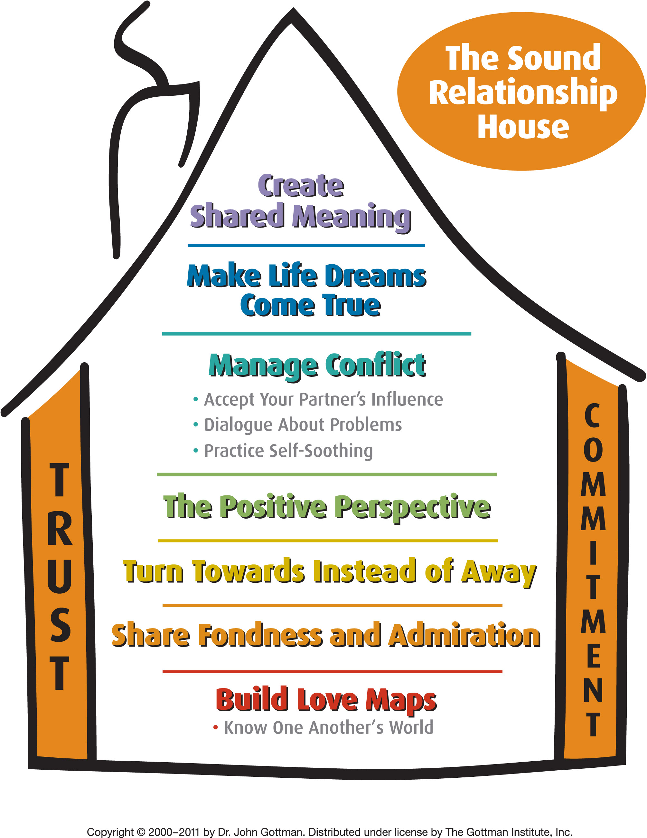
Build Love Maps: How well do you know your partner’s inner psychological world, his or her history, worries, stresses, joys, and hopes?
Share Fondness and Admiration: The antidote for contempt, this level focuses on the amount of affection and respect within a relationship. (To strengthen fondness and admiration, express appreciation and respect.)
Turn Towards: State your needs, be aware of bids for connection and respond to (turn towards) them. The small moments of everyday life are actually the building blocks of relationship.
The Positive Perspective: The presence of a positive approach to problem-solving and the success of repair attempts.
Manage Conflict: We say “manage” conflict rather than “resolve” conflict, because relationship conflict is natural and has functional, positive aspects. Understand that there is a critical difference in handling perpetual problems and solvable problems.
Make Life Dreams Come True: Create an atmosphere that encourages each person to talk honestly about his or her hopes, values, convictions and aspirations.
Create Shared Meaning: Understand important visions, narratives, myths, and metaphors about your relationship.
Trust: this is the state that occurs when a person knows that his or her partner acts and thinks to maximize that person’s interests, and maximize that person’s benefits, not just the partner’s own interests and benefits. In other words, this means, “my partner has my back and is there for me.”
Commitment: This means believing (and acting on the belief) that your relationship with this person is completely your lifelong journey, for better or for worse (meaning that if it gets worse you will both work to improve it). It implies cherishing your partner’s positive qualities and nurturing gratitude by comparing the partner favorably with real or imagined others, rather than trashing the partner by magnifying negative qualities, and nurturing resentment by comparing unfavorably with real or imagined others.
The Well

Go Deeper with God and Others

Prepare for or Enrich Your Marriage
Facilitator: Vinnie Cappetta Cost: $10 per person
Three million other couples have completed this program. National studies demonstrate this program is highly effective to help you develop your strengths and overcoming ongoing issues. Identify your strengths and growth areas, dialogue about your relationship in meaningful and productive ways, increase practical relationship skills in communication, conflict resolution, closeness, flexibility, and financial management. Increase your understanding of personality, affection, sex, and your family or origin. Includes an online assessment, small group discussion and generous time for you and your spouse to discuss issues and build your skills alone.

The Emotionally Healthy Woman: Stop Pretending & Change Your Life
Facilitator: Heather Cappetta Cost: $10
Allow the Lord to help you identify and quit behaviors that are lethal to your soul. Follow the Holy Spirit’s guidance for grace and courage to make lifestyle changes to quit certain unconscious ways of living. Rediscover biblical truths that have been misconstrued and neglected. Begin living a Gospel-centered life rooted in God’s love for you. Topics include: fear of others, deception, anger, sadness, blaming, over functioning, faulty thinking, and living your unique life.

Wednesdays, February 5th - April 30th
Dinner 5:55 | Groups 6:40-8:00pm

Kids at The Well
Nursery: Infant – Preschool
JAM (Jesus And Me): Kindergarten – Grade 5

